Chevy Big Block
INSTALLATION METHOD FOR SERPENTINE KIT
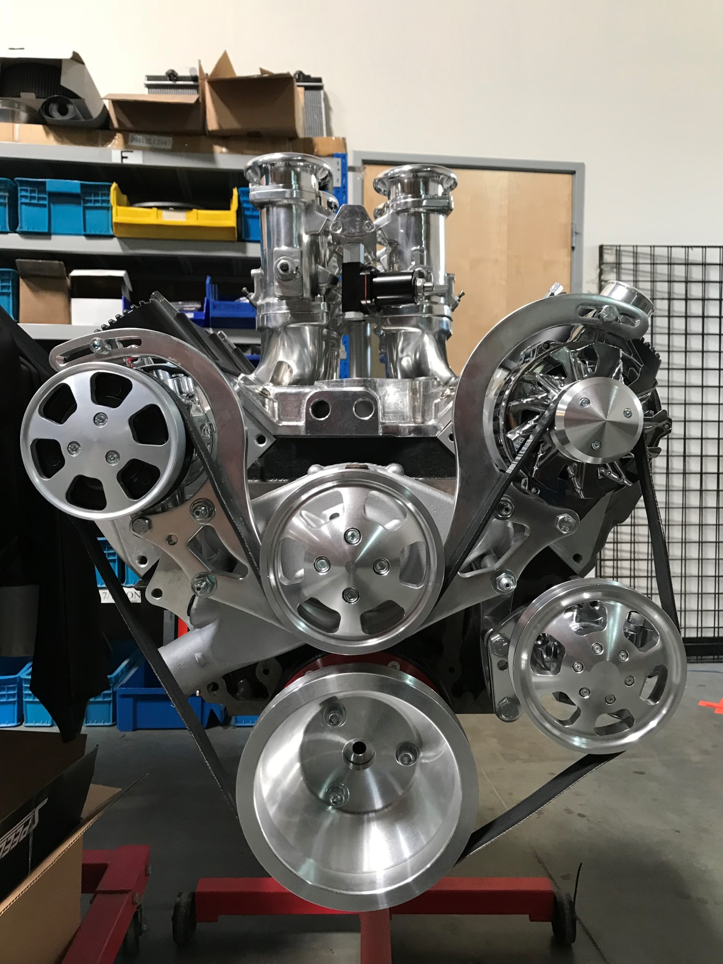

Pulley Kit Installation
PREPARATION FOR INSTALLING PULLEY KIT
- Disconnect battery and remove it entirely as you will be disconnecting the lead from the back of the alternator later.
- Drain power steering fluid and engine coolant.
- Remove entire existing belt drive setup from your engine including crank pulley, alternator, AC compressor (if equipped), power steering pump (if equipped), water pump and all brackets.
- Clean all mating surfaces thoroughly.
Note: Please use extra caution while handling, unpacking, and installing new components so you do not damage the finish.

INSTALLING WATER PUMP

- Install the four new mounting studs to the block. (See Figure 1)
Caution: When tightening the four studs be mindful of the blind holes. Over torqueing the blind holes may crack the block.
Note: Use the two included hex nuts tightened against each other to act as a drive nut to ease installation (see illustration below)
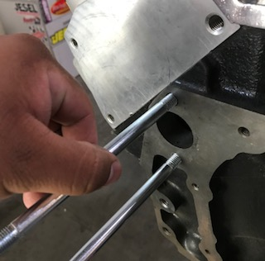
Figure 1

- Slide the air compressor bracket on the water pump studs on the passenger side and seat against the block. (See Figure #)

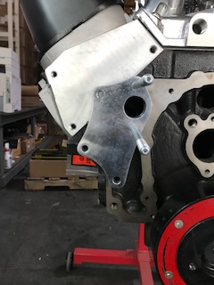
Figure 2

- Slide the alternator bracket on the water pump studs on the driver side and seat against the block. (See Figure 3)

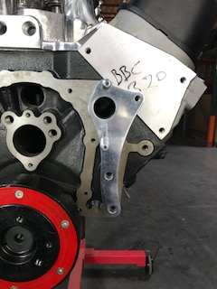

Figure 3

- Slide the water pump, with the gaskets, over the studs and seat against the block. (See Figure 4)

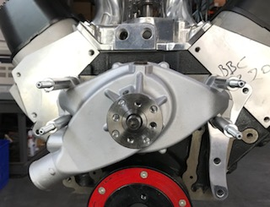

Figure 4

INSTALLING THE BRACKET

- Install the four spacers on the studs. (See Figure 5)

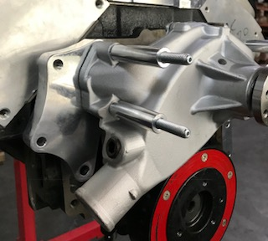
Figure 5

- Align the four studs to the four holes on the pulley bracket and slide on the bracket. Mount the bridge bracket in the correct position, as shown. (See Figure 6)

NOTE: The bridge bracket has a recessed portion on the alternator side. That recessed portion must be on the back side of the bridge bracket on the driver side of the block.

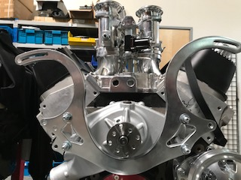
Figure 6

- Use the four 9/16” nuts to firmly tighten the bridge bracket. (See Figure 7)

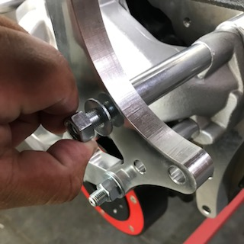
Figure 7

INSTALLING WATER PUMP PULLEY

- Use the four 6mm socket head cap screw bolts to tighten down to 16 ft-lbs.
(See Figure 8)

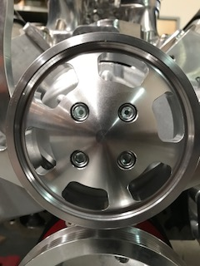
Figure 8

INSTALLING THE CRANK PULLEY

- Mount the crank pulley with the spacer. (See Figures 9 and 10) Seat the spacer against the damper.

NOTE: The raised portion of the crank pulley sits in the recessed portion of the spacer.

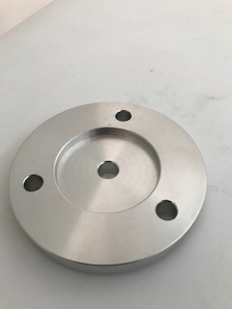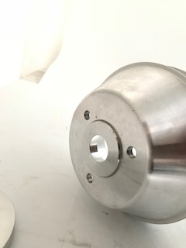
Figure 9 Figure 10

- Use the three 8mm bolts to tighten the crank pulley assembly to 30 ft-lbs (See Figures 11 and 12)
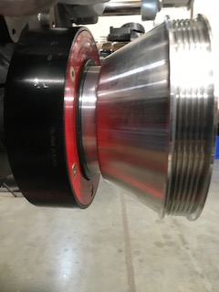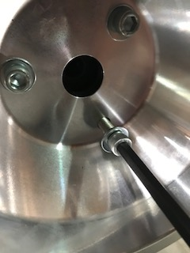
Figure 11 Figure 12

INSTALLING THE AIR COMPRESSOR

- Mount the air compressor in the top left location of the bridge bracket.
(See Figure 13)

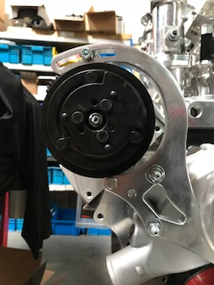
Figure 13

- Use the 6mm socket head cap screw and 14mm nut and bolt to firmly tighten down the air compressor.

NOTE: Thread the 6mm socket head cap screw through the top slot of the bracket and compressor. Use the 14mm bolt on the bottom hole of the bridge bracket.

- Install the air compressor cap; use the three 5mm bolts to firmly tighten the cap.
(See Figure 14)

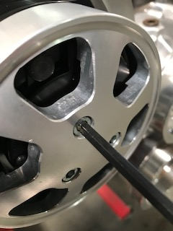
Figure 14

INSTALLING THE POWER STEERING PUMP

- Use the two small spacers with the 5/8” bolts to firmly tighten down the power steering bracket. (See Figures 15 and 16)
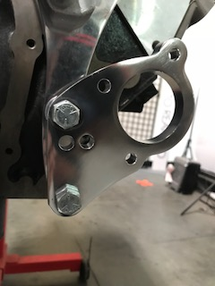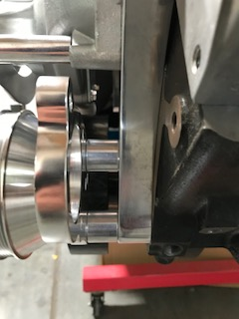
Figure 15 Figure 16

- Mount the power steering pump and using the two 6mm socket head cap screws tighten firmly through the rear of the bracket. (See Figure 17)

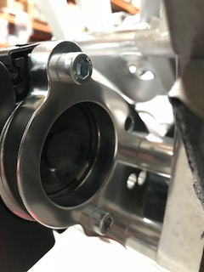
Figure 17

- Install the power steering pulley then tighten the 6mm bolts firmly. (See Figures 18 and 19 )
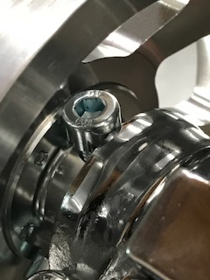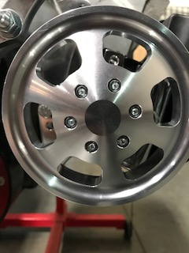
Figure 18 Figure 19

INSTALLING THE ALTERNATOR

- Mount the alternator in the correct position. (See Figure 20)

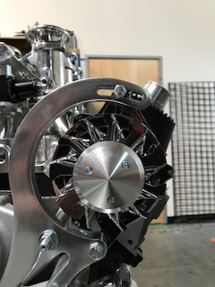
Figure 20

- Use the 1/2" bolt to firmly tighten down the alternator and use the given bolt that comes with the alternator to tighten it.

NOTE: Run the 1/2" bolt through the top hole of the bracket and alternator. Use the given bolt on the bottom slot of the bridge bracket.

INSTALLING THE SERPENTINE BELT
- Route the belt as shown.
